* **Hybrid Mobile App's Development Tools:**

The time has never been better to learn mobile application development. For many app ideas, you don’t even need any prior native development knowledge. You can get started today with knowledge of HTML, CSS and JavaScript. Unlike native mobile development, mobile applications using web technologies can support many mobile platforms. There are many tools and framework available to help you create Mobile applications.

1. **PhoneGap (Apache Cordova):**

[PhoneGap](http://phonegap.com/) is probably the most well known among hybrid app platforms and probably the easiest to begin with for a web developer. [Cordova](https://cordova.apache.org/) is the open source foundation and engine of PhoneGap. It’s backed by Adobe and is completely open source. It lets you create cross-browser mobile applications with Javascript, HTML, and CSS. These apps run in a WebView and are then wrapped in native code. PhoneGap then offers native plugins that allow you to use all of the device’s functionality including accelerometer, camera, compass, file system, microphone, media, networks, notifications, geolocation, and storage. Apps need to be packaged into binary files which will include a webview wrapper and your app’s HTML files, normally loaded locally on the device.

PhoneGap (distributed by Apache Cordova) is a hybrid app development framework that also allows you to compile and deploy apps across multiple platforms. When used with frameworks to develop hybrid apps, developers can harness the power of Cordova’s plugins, which allow hybrid frameworks to connect apps to native APIs like a phone’s accelerometer, GPS, camera, notifications, and more for a more native experience. Hybrid frameworks like Ionic, Onsen, etc. also use Cordova to compile their HTML/JavaScript/CSS app code into a native SDK file format. There’s a free plan, or a paid plan that offers increased data and access to more plugins.

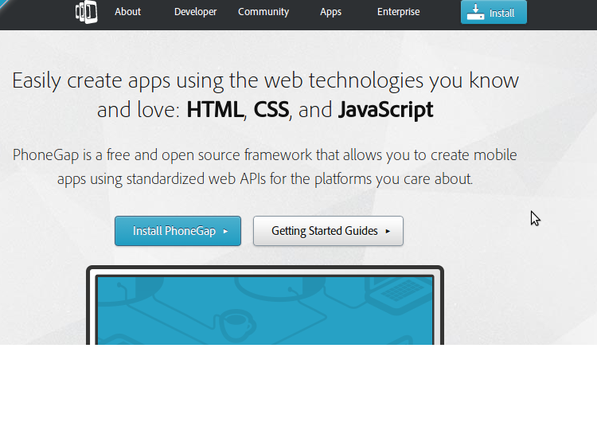

[PhoneGap](http://phonegap.com/) is the odd one out in this list as it’s not a framework for creating an app, but for packaging and releasing an app. PhoneGap is based on the open source [Cordova](http://cordova.apache.org/) and is the commercial version owned by [Adobe](http://www.adobe.com/). With a dedicated support team, PhoneGap is popular amongst many mobile developers.

You can use any choice of JavaScript or UI frameworks to get started with PhoneGap. [jQuery Mobile](http://jquerymobile.com/) alongside [KnockOut.js](http://knockoutjs.com/) or [AngularJS](http://angularjs.org/) is a nice combination. Once you are done with your code, PhoneGap takes it from there and wraps it based on the intended platform. Applications built using PhoneGap use a web view to render their content. PhoneGap has a minimal set of web APIs to access phone hardware features and it’s possible to write custom plugins to suit requirements.

1. **Ionic Framework:**

IONIC is one of the most promising HTML 5 mobile application frameworks. Built using [SASS](http://sass-lang.com/), it provides many UI components to help develop rich and interactive apps. It uses the JavaScript MVVM (Model view view model) framework, [AngularJS](http://angularjs.org/) to power apps. Two-way data binding, interaction with backend services and APIs makes AngularJS a mobile developer’s common choice.

This HTML5 hybrid mobile framework has the added bonus of AngularJS components, a robust JavaScript framework that allows Ionic to power some really complex, scalable apps. Ionic is free, open-source, and all of its components—HTML, CSS, and JavaScript—have been optimized for mobile. The framework stays on the leading edge with frequent updates, including recent built-in support for material design, Google’s design standard for Android apps. To push the web code to a native environment, Ionic, like many other frameworks, uses the Cordova JavaScript APIs.

The first representative we decided to touch upon today is known to everybody. It is a highly respectable open source platform which has been constantly updated, providing its users with contemporary features and satisfying all trends of modern hybrid application development. We must mention that its tremendous community which stores lots of useful material is able to assist you whenever there is a problem popping up.

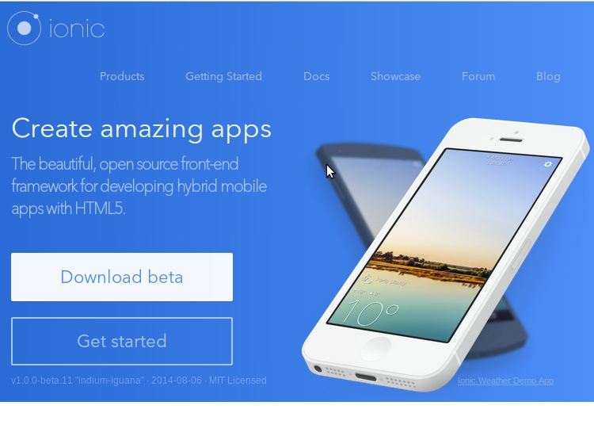

Besides, it will certainly attract you by Angular framework availability and other out-of-the-box tools that are capable of creating a great impact on application development process, giving you huge power in your hands. To go native, Ionic enjoys using Cordova, however, it is actually widely utilized one.

Of course we couldn’t help mentioning Ionic’s default pack which already provides you with amazing JavaScript and HTML components as well as highly mobile-optimized library of CSS.

1. **Sencha Touch 2:**

[Sencha Touch](http://www.sencha.com/products/touch/) is an HTML 5 mobile app framework for creating apps for several platforms including iOS, Android and Blackberry. It has been in existence for some years now and is popular among hybrid mobile application developers.

With hybrid app programming, the end goal is often to make the app feel as close to native as possible—and Sencha Touch achieves this with HTML5-based front-end technology and lots of built-in tools. The cornerstone is its responsive user interface (UI), and you’ll end up with clean, organized code thanks to the object-oriented, MVC-style structure of the framework. Need enterprise-grade apps? Sencha is a good choice. If you’re building more complex applications, you’ll benefit from Sencha’s great documentation, but note that the complexity of using this framework will increase right along with the complexity of your app.

Sencha Touch is an enterprise which enjoys high consideration of diverse companies and in fact it is a great choice for hybrid application development, however not for individual developers or freelancers since it is rather expensive. In this case, we believe that ionic may be utilized instead.

Even though, it is not that cheap to acquire the products of this company, we should say that it genuinely pays off. For instance, ExtJS, highly regarded JavaScript framework lies in the heart of Sencha Touch Platform, providing you with the ability to develop applications of high performance, giving the feeling as if it was native experience. Besides, a wide diversity of widgets, included in the pack, will satisfy your demands in respect of creating native look and feel for world recognized platforms such as Android, Windows Phone, Blackberry, iOS etc. If you are searching for ready to use templates, Sencha Touch template list availability will appeal to you as well as its drag and drop HTML5 visual app builder.

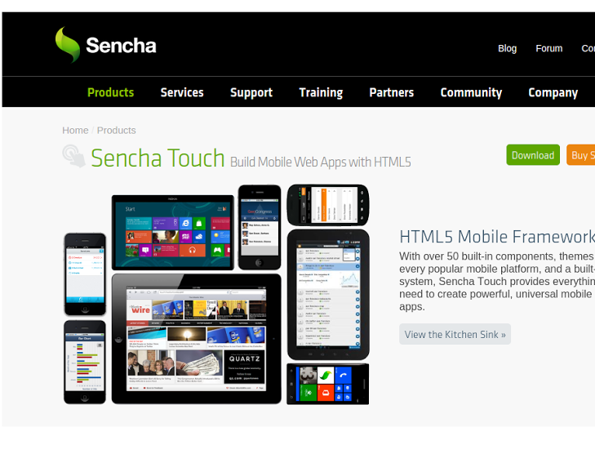

Sencha Touch scores highly against it’s competitors by providing a native look and feel across all of the platforms it supports.

Getting started with Sencha Touch isn’t that difficult but in order to get the best out of Sencha Touch, one needs to invest a considerable amount of time.

1. **React Native:**

Facebook’s popular ReactJS JavaScript library is running under the hood of this mobile framework, built specifically to design natively rendered UIs for iOS and Android. Any developer who knows JavaScript can work with React Native, and it’s fast, streamlined, and feels more native—without requiring a WebView. Instead, native components are built with web technology. A React Native-designed UI can be incorporated into an existing mobile app’s code, making it more like a library than a framework, but it’s still packed with extras that make styling, debugging and deploying your app into the App Store or Google Play a breeze. React Native is proving to be a big game-changer in mobile development, blending the productivity of web technology with the functionality of native apps.

1. **Onsen UI Framework:**

OnsenUI is hot on the heels of Ionic, with AngularJS components as well, but it also offers jQuery components, the “write less, do more” JavaScript library. Like Ionic, OnsenUI also relies on Cordova for native compatibility.

Onsen UI is a quite popular tool and you might have heard of the flexibility it can provide you with. This flexibility is defined by the ability to choose which framework you want to work with – Angular or jQuery. it is an open source platform that can be utilized under Apache license. Furthermore, we would like to say that nowadays it is gaining momentum and in future it may even become a threat to Ionic. Besides, Onsen fascinates its users due to its out-of-the-box  responsive components will greatly facilitate the process of hybrid mobile application development. Even though, we use web-development tools such HTML5 and JavaScript to realize new project idea, it is not complicated to go native, since you can easily utilize Cordova or Phonegap.

Honestly speaking, a great number of people rest hope their hopes upon its advancement and success in comparison to surrounding competitors.

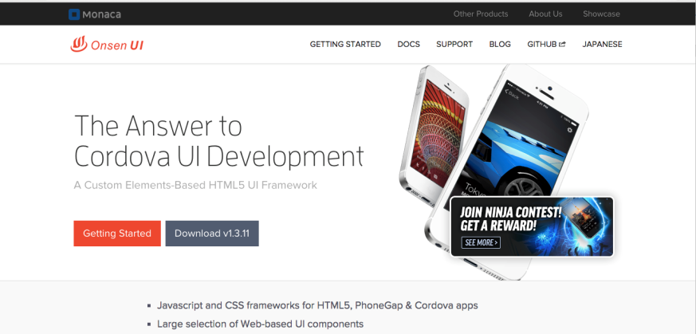

1. **jQuery Mobile:**

Taking jQuery’s “write less, do more” approach, mobile developers released jQuery Mobile, a compact framework that hinges more on fluidity between mobile and web application versions and unique UIs for each platform, but less on trying to create a super native experience. It uses an HTML5-based UI and customizable themes that get a boost from CSS3’s newer functions. This JavaScript framework lets developers create one version of an app that’s responsive and works across all devices and platforms and is one of the older hybrid frameworks.

jQuery has been worthily demonstrating its dignity to mobile application development community, defending itself from competitors. It has appeared thank to devotion of jQuery users who worked hard to revive their “colleague” and nowadays It completely relies on the firm jQuery and jQuery UI foundation.

The principal focus of jQuery Mobile is not guarantee a native look but rather provide you with an impeccably smooth functioning of your mobile, desktop, and tablet applications.

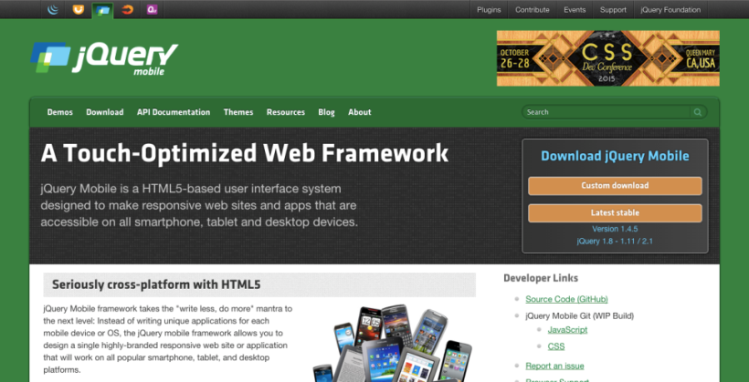

1. **AngularJS:**

It works well with other libraries and is fully extensible, making it easy to take your mobile app to the next level beyond the static capabilities of HTML. AngularJS allows you to extend beyond HTML vocabulary to build very fast dynamic views.

1. [**ADOBE AIR**](https://www.upwork.com/o/profiles/browse/skill/adobe-air/)

This Adobe mobile app development platform is pretty high-powered, using front-end languages like HTML and JavaScript, making it easy to pick up, but also adding in some Adobe-specific technology, like Flash, Flex, and ActionScript. It uses a runtime environment that’s compatible with OS X, Windows, and Linux. Like Java’s runtime environment, [Adobe AIR](https://www.upwork.com/o/profiles/browse/skill/adobe-air/) uses a just-in-time (JIT) compiler which allows your app to run across different platforms. It also offers a range of APIs that give developers access to functions like database management.

1. [**KENDO UI**](https://www.upwork.com/o/profiles/browse/skill/kendo-ui/)

[Telerik’s](http://www.telerik.com/) [Kendo UI](http://www.telerik.com/kendo-ui) is an HTML 5 framework for creating cross platform mobile applications. Kendo UI relies heavily on jQuery and has a number of jQuery based widgets.

Utilizing HTML5, JavaScript and CSS to create hybrid mobile as well as web applications, with Kendo UI you are capable of developing high quality products since this particular one is renowned for its wide cooperation with other frameworks, allowing you to absorb only the best features and characteristics. It is dramatically interlinked with jQuery, therefore in its pack you receive more than 70 jQuery widgets, as well as you are able to integrate Kendo with Angular and Bootstrap UI frameworks. The privilege to apply Kendo while the hybrid development process consists in custom theme builder availability, making things easier. As regards licensing, Kendo UI provides its users with open source and commercial versions. But, the free one is obviously limited to some extent, disabling several features and giving less devoted technical support.

Kendo UI is an impressive platform for building both hybrid and native mobile apps, with a unique capability: developers can use client-side technology like HTML and JavaScript, or they can build an app with server-side technology like Java, PHP, and ASP.NET—thanks to Kendo’s range of UI components that come with its mid-level subscription plan, the Complete License.

Other Kendo basics? It has full AngularJS integration, or allows developers to use almost any JavaScript framework they prefer, and also offers support for Bootstrap 3 for mobile-friendly, responsive apps. As far as design goes, it includes 16 themes, or you can customize with the ThemeBuilder tool.

To underline its significance on the market still, we would like to mention that Kendo UI is looked upon by diverse enterprises and in fact is utilized by giant companies and organizations such Sony, NASA, Microsoft, Toshiba, Volvo etc.

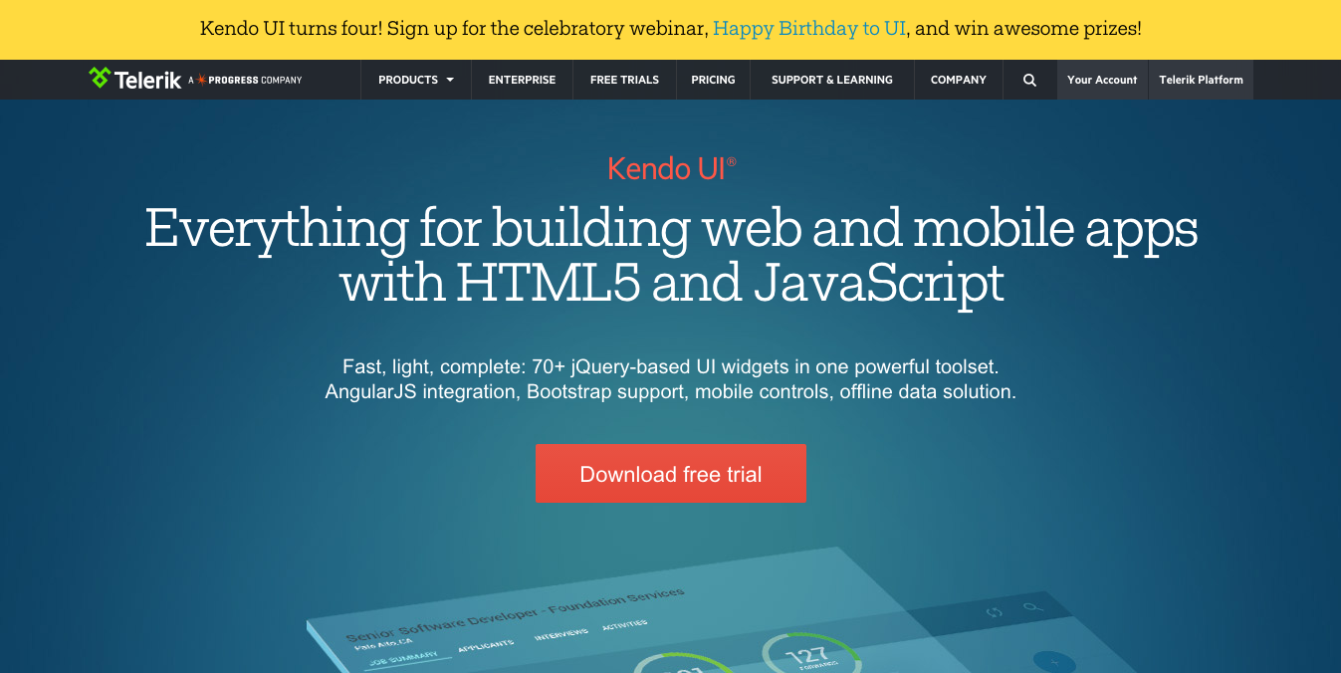

Learning Kendo UI is not difficult, developers familiar with jQuery will find Kendo UI easy to learn. [Kendo UI has open sourced](http://techcrunch.com/2014/04/18/telerik-open-sources-most-of-its-kendo-ui-html5-framework/) most of Kendo UI’s toolset and JavaScript framework features. However most of the commonly used widgets are still under a commercial license.

1. [**Mobile Angular UI**](http://mobileangularui.com/)

Mobile angular UI is a free hybrid mobile app development tool which allows you to build HTML5 Mobile Apps with Bootstrap and Angular JS. It’s very similar to Sencha Touch and jQuery Mobile. It uses [bootstrap 3](http://getbootstrap.com/) and [AngularJS](http://angularjs.org/) to create interactive mobile apps.

The main features of Mobile AngularUI include:

* Bootstrap 3
* AngularJS
* Bootstrap 3 mobile components such as switches, overlays and sidebars which are missing in normal bootstrap.
* AngularJS modules such as angular-route, angular-touch and angular-animate

Responsive media queries are stripped out of bootstrap as separate files, you only need to include what you need. Mobile Angular UI doesn’t have any jQuery dependencies, all you need are some AngularJS directives to create awesome mobile user experiences.

If you work a lot with Bootstrap 3 and Angular framework for the hybrid application development, you are able to make the most of Mobile Angular UI, since their cooperation is so solid and actually it is unsubtle to everybody. To provide you with great mobile experience, it prefers using fastclick.js and overthrow.js. Besides, Angular UI is regarded to be kind of extension to Bootstrap, however there are no jQuery or bootstrap.js dependencies

In fact, Mobile Angular UI includes different components such as: sidebars, scrollable areas, overlays, switches etc. which will assist you in creating an HTML5 awesome mobile application, making the development process easy and pleasant. As we know, Bootstrap 3 falls short of such elements, thus we can say that they perfectly complete one another. . It retains most of the Bootstrap 3 syntax. This way it’s trivial to bring an existing desktop web app to mobile. Also a super-small css file is provided to do the opposite. Just include it and you’ll get a fully responsive and touch enabled interface that can be used everywhere.

Mobile Angular UI is an open source platform, when it comes to licensing Angular reminds us Framework 7 since it is utilized under the same license – MIT license.

It also provides switches, overlays, sidebars, scrollable areas, and absolute positioned top and bottom navbars that don’t bounce on scroll, and makes for easy mobile to desktop and back transition. The only drawback is the documentation isn’t quite up to par, but they’re working on updating it.

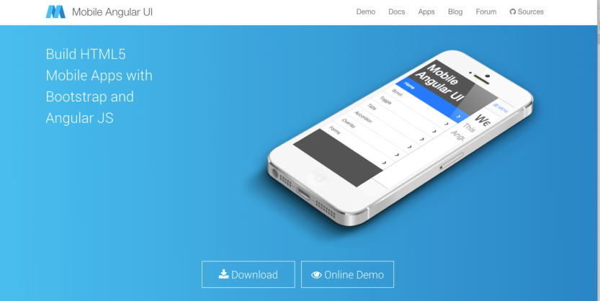

## [Intel XDK](https://software.intel.com/en-us/intel-xdk)

[Intel XDK](https://software.intel.com/en-us/html5/tools) is a cross platform application tool developed by Intel. Getting started with Intel XDK is easy, all you need is to download their application which is free and available for Linux, Windows and Mac. It provides a number of templates to get started and supports a number of UI frameworks such as [Twitter bootstrap](http://getbootstrap.com/), [jQuery Mobile](http://jquerymobile.com/) and [Topcoat](http://topcoat.io/).

Intel XDK provides a live preview on the connected device whilst you are developing along side many other useful tools.

Since Intel Corporation has performed incredible results in computing industry. In fact, without any kind of exaggeration, we believe that it is extremely potent and outstanding platform for it comprises lots of utile features, tools and amazing frameworks that come in handy during the hybrid app development process, simplifying such procedures as debugging, emulation, testing etc.

What we find marvelous about Intel XDK is app framework availability which includes a big deal of ready to use components aimed at assisting targeted platform adaptation. It is able to provide you with template support for iPhone, iPad, Windows Phone, BlackBerry and Android applications. However, Intel XDK does not bound its spectrum of abilities to app framework, as it also cooperates with jQuery (as well as Onsen does), Bootstrap 3 and Topcoat UI frameworks.

Having provided you with the insight on its enriched features kit, we are able to state that it is actually capable of taking over the application development market. Moreover, the number of developers utilizing Intel XDK is constantly increasing. Let’s see what future will bring to us.

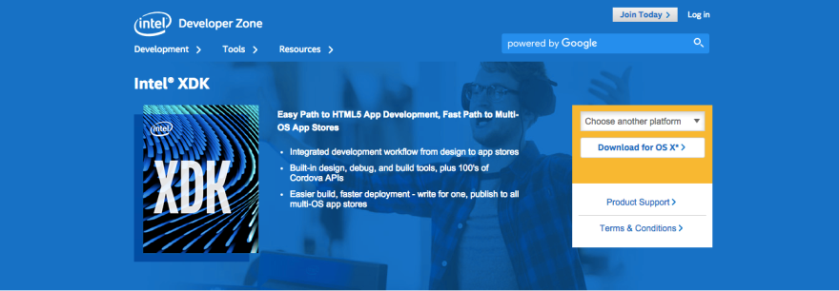

## [Framework 7](http://www.idangero.us/framework7/#.Vh_EjBOqqko)

Framework 7 is an open source potent framework which appeals to developers due to its power concentration on a particular field. We are not afraid to state that it is considered to be a prominent one among hybrid application development tools for iOS platform. By using CSS, HTML and JavaScript you are able to create nearly native iOS applications. In comparison to the aforementioned frameworks this one differs in its abilities to work with other platforms, excluding iOS obviously. However, there is something it can please you with, since the Framework 7 pack comes with amazing out-of-the-box features (e.g swipe back) you will definitely suck an advantage out of. Apart from it, the framework will fascinate you with diverse UI components such as: media lists, side panels, models, list views etc. As we have already mentioned that it is a open source framework, it can be applied in accordance with MIT license.

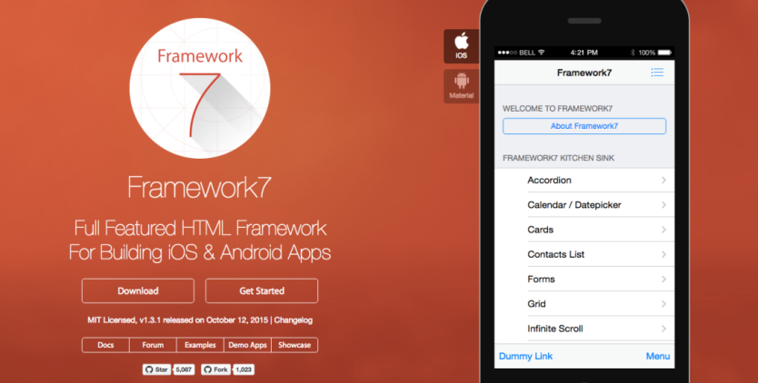

## [Famo.us](http://famous.org/)

Famo.us is a great HTML5 application development tool which concentrates its attention particularly on the rendering of graphics, 3d and 2d , therefore you can be sure that this platform will perfectly suit games development. It certainly cares a lot about providing you with as much closer to native experience apps as possible.

## [Monaca](https://monaca.io/)

This one is renowned in the commercial space and has already gained its position in the market. In fact, Monaca features an enormous variety of modules and components, therefore just right out-of-the-box you acquire a great deal of material to work with. To go native, Monaca uses Cordova, basically as the major part of other mobile hybrid app. development platforms. It is worth mentioning that Monaca is capable of simplifying the process of application development, since it provides you with cloud-powered tools and services. Besides, the spectrum of its abilities will appeal to you, as you can start writing and implementing your project idea from the scratch and till the very end.

However, there are still some things Monaca can surprise you with. As the matter of fact, while utilizing Monaca, we can observe such a deep integration with Onsen Framework. But it doesn’t mean at all that you cannot use other frameworks.



## [Trigger.IO – the Dark horse](https://trigger.io/)

Of course, while talking about the best hybrid mobile application development platforms, we couldn’t help touching upon Trigger.IO. Why?

As the matter of fact, we would say that it rather stands out from the crowd and demonstrates its uniqueness. Having covered all the tools mentioned above, we could observe the situation, that lots of them apply Cordova or PhoneGap for native access. However, in case with Trigger, it suggests us using another tool, called Forge JavaScript API which is virtually said to perform better results in comparison to what Cordova and PhoneGap do.

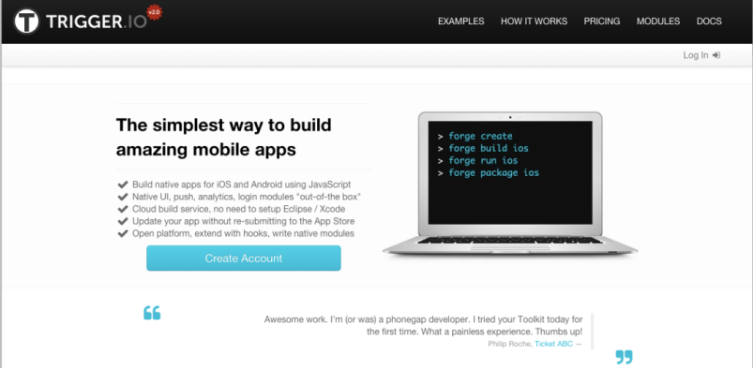

#### ****Canvas****

Our own take on the hybrid app, [Canvas](https://www.mobiloud.com/wordpress-mobile-app/) is a service offering anyone with a mobile web app or responsive site the ability to build a mobile app for it, with no development work. As with our [News](https://www.mobiloud.com/wordpress-news-app/) solution, it’s offered as a service, meaning we will build, publish and maintain your apps for you. Technically, [Canvas](https://www.mobiloud.com/wordpress-mobile-app/) relies on our own native codebase for iOS and Android, including native elements for navigation such as a tab bar, functionality like a push notifications inbox, content preloading for your pages, caching and offline support. The app is designed to rely on a remote web app or mobile site which you control – any change on your mobile site is immediately reflected in the app.

## Appcelerator Titanium

[Appcelerator’s Titanium](http://www.appcelerator.com/titanium/) is an open source mobile application framework that provides an environment to create native apps for several mobile platforms

Titanium is a complete solution for creating hybrid mobile apps with all you need in one place. To get started with Titanium download [Titanium studio](http://www.appcelerator.com/titanium/titanium-studio/). The Titanium SDK is equipped with a number of mobile platform APIs and Cloud service to use as an app backend. It comes with platform independent APIs which makes it easier to access phone hardware.

Titanium uses [Alloy](http://www.appcelerator.com/titanium/alloy/), a MVC framework to enable rapid development of mobile apps. Modules created using Alloy are easy to reuse across different apps, hence significantly reducing the development time and the lines of code.

Titanium studio comes with some [code samples](http://docs.appcelerator.com/titanium/3.0/#!/guide/Titanium_Samples) to get started and we hope to have a tutorial on SitePoint soon.

### Conclusion

To sum it up, the first thing you should notice is that hybrid application development is gaining momentum, as it features the approach of writing once & running everywhere. That is why a big deal of developers are walking out on native languages, for they feel kind of restricted.

* Skip
* [app.js](http://code.kik.com/app/2/index.html) is a JavaScript library for creating mobile web apps. It’s lightweight and unlike other frameworks, doesn’t use AngularJS. It provides several custom themes and widgets. You can write the app using [zepto](http://zeptojs.com/) or [jQuery](http://jquery.com/). A good starting point is [An intro to App.js](http://www.sitepoint.com/intro-app-js-mobile-webapps-made-easy/).